
727th AMPHIBIAN TRACTOR BATTALION ASSOCIATION

300 Anders Camp Road
Cleveland, SC 29635 Phone: (864) 836-3436

September 2021
Dear 727th ATB Family and Friends:

We hope you are taking care and being safe during this COVID-19. This is a newsletter that is sent to those without email accounts. If you have an email address, please make a contact with Karen DeVictor. Emails are sent out when news is shared, so you would have information earlier.

Please remember that if you have any information to let Karen Corbin DeVictor know. Her e-mail is: kdevictor@gmail.com, or call 785-842-8216. You are welcome to call any time. We will make sure and keep you informed through emails or through newsletters. If your contact information has changed, please let us know so we can continue to keep in touch.

OUR 727th ATB WEBSITE IS: http://www.727atb.com.
Terry Sorenson is our Historian and Webmaster. You are always welcome to send
information and pictures to him so he can add these to our website archives.
His email is: terry@bankononb.com

NEWS SINCE THE LAST NEWSLETTER-July 2020
2020

- July 14 Ann received a phone call from Tim Sieben. He is the cousin of Ed Locke. Great to hear
from him and he was thankful for receiving a newsletter. He sent some pictures from
past reunions and he is now on Karen’s mass email list. I also have his address and phone
number.
- July 15 Karen received an email from Josephine Feigal (Walter) today. She has moved to a nice
apartment and now has a new address. Her phone number and email are still the same.
Her new address is: 2540 Kenzie Terrace, Apt 308 St. Anthony, MN 55418. She said,
“Greetings to all. Love from me and my family.” All the best wishes to you, Josephine!
- July 16 Karen received an email from Doris, wife, and Julie, daughter,Nachman (Elias Nachman).
Elias passed away February 16, 2018. Doris is now living at: 1520 E. Bates St. #215,
Springfield, MO 65804. Her email is: adnachman@gmail.com . Julie is at: 4000 Cathedral
Ave NW, #7078, Washington DC 20016. Her email is: jnachman@gmail.com. We extend
our deepest sympathy to Doris and Julie for the passing of Elias.
- July 16 July 2020 Newsletter was returned to Ann from Cecil Doran. I have: P.O. Box 106, New
Hope, AL 35760. If anyone has current information, please let us know.
- July 20 July 2020 Newsletter was returned to Ann for Orville Bowersox. I have: 927 Siminole Rd.,
Frederick, MD 21701. If anyone has current information, please let us know.
- July 22 July 2020 Newsletter correction is needed to be made. For the May 21 entry about John
Rauert’s 2016 video, I accidentally wrote “John Ahlstrand” and his name is “Norman
Ahlstrand”. Thank you for letting me know so I can make sure and have this corrected.
- Aug. 16 Ann received an email from Nalani Kittel, daughter of Charles Bohannan (wife-Betty). He
passed away August 12, 2012, but I did not have the information that her mother had also
passed away (June 12, 2020). Nalani’s address is: 2570 E. Montebello Dr., Sandy, UT
84092 and her email address is: nalanij@aol.com. We wrote several emails back and forth.
She said her dad was supposed to outlive her mom, so when he died it was sudden. Nothing
wrong with him-just took the nose dive from being well to passing on fast. He was almost 90.
Her mom passed away at the age of 99-thought she would live to 100. She was still
balancing her checkbook, sharp as could be, and gave up driving at 98 years old. She felt
luckier than most at having them so long, but still hard to have them gone. I know she’d love
to hear from anyone that remembers her parents and getting on our newsletter list.
- Sept. 16 Email was received from Harry Lew today. He has a new email address, so please make a
change to your information. It is: hl8011@gmail.com. Thanks, Harry, for keeping us in the
loop!
- Dec. 22 Karen received an email from the Josephine Feigal (Walter) family. She has moved
permanently to an assisted living facility. We had this address in July, but some 727th mail is
still coming to her old home place and is no longer being forwarded. Please change your
address. Her email and phone number remain the same. Her new address is: 2540 Kenzie
Terrace, Apt. 308, St. Anthony, MN 55418.
- Dec. Ann received a Christmas letter from Bev VanKirk (Frank). She’s keeping
in touch with others using Zoom and updated all the fun changes with her family. Looking
forward to a wonderful 2021! Merry Christmas to you, Bev.
2021

- Apr. 10 Harry Lew was presented the Congressional Gold Medal of Honor. Congress awarded this
special medal to roughly 20,000 Chinese Americans who served during WWII. Harry is
one of approximately 300 Chinese American veterans still with us. How proud we are!
- Apr. 19 Karen received an email from Terry Sorenson. His mother, Arleen, widow of Wilbur H.
Sorenson, was admitted to the hospital on Friday. She had not slept well and was
agitated, so the care center had her taken to the ER, where she was admitted for monitoring.
Tests were inconclusive and doctors say there is no medical reason for this change in her.
Now, she is refusing food that is presented to her. Please keep Terry and his brother, Dean,
in your thoughts. You can communicate with them: Terry Sorenson (wife Vicki Allen) email:
terry@bankonnonb.com. Address: 1510 Willow Point Lane, SW, Rochester, MN 55902 and
Dean Sorenson (wife Karen Thorsen) email: deansorenson@me.com. Address: 28180
Hopewood Dr., Northfield, MN 55057.
- Apr. 25 Karen received an email from Terry Sorenson. His mother passed away yesterday, April
24th. Here is the website to her obituary-this may be still able to be seen and read.
https://www.ewingfh.com/obituaries/arleen-I-zingg-sorenson/. Terry and all his family are in
the thoughts and prayers of many. Arleen had attended several reunions in the last decade
and so enjoyed renewing friendships. She had a beautiful halo of white hair and an even
more beautiful smile.
- Aug 25. Karen sent out an email today. She had a phone call from Christine Torrez yesterday and
she told her that her husband, Bennie Torrez, passed away Saturday, August 21, 2021.
The family has planned a small service with military honors for him. Christine also mentioned
that their son was just diagnosed with lung cancer. We will keep him in our prayers. You can
contact her: 106 South 13th Street, Cottonwood, AZ 86326. Her phone is 928-634-3381.
Our thoughts, prayers and deepest sympathy, go out to Christine and all her family.
- Aug. 25 Karen talked with Cora Alvarez (“Poncho”). Cora said her brother, Mike, who lived in
Arizona passed away in April. Our deepest sympathy to you, Cora, and your family. She
is a faithful friend who is always thinking of others and sends cards out to many of us.
She is still cleaning offices some mornings and stays positive about herself. She’d love to
hear from others. Call her anytime to chat-she’s even up ‘til midnight! Her phone is:
316-283-9386.
- Aug. 30 Karen heard from Cheryl and Ted Turner, daughter of Howard Jessen. They are staying
well, but regretted having to postpone travel and visits with family often, during the
pandemic. Cheryl said they appreciated updates from the vets and families, and though
she was sorry to hear about Bennie, she said that he has now rejoined the group of men
who went on before, and noted that Bennie was very close to her dad.
- Sept. 3 Karen received an email from Margarita Carroll, daughter-in-law of Francis Carroll. She
said he would love any communication from others. He is now living at: D’Youville
Senior Care, 981 Varnum Avenue, W112, Lowell, MA 01854. He has been through Covid,
pneumonia, kidney infections that led to sepsis and continues to come out on top! He
celebrated his 96th birthday this past July. Congratulations, Francis. Best wishes to you!
Thank you, Margarita, for all your news about Francis. Give him a call sometime.
His number is: 978-500-8209. Margarita’s email is: margarita.b.carroll6@gmail.com.

Love and God Bless you all,

Ann Edwards & Karen DeVictor (Merritt Corbin’s daughters)
Email: anncedwards@gmail.com
Phone number is: 864-836-3436
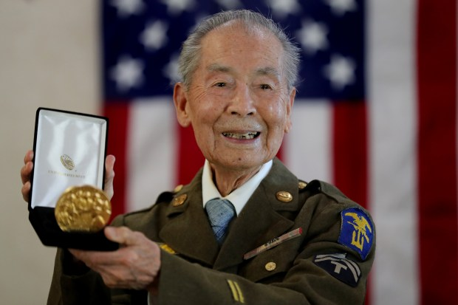
Harry Lew receiving the Congressional Gold Medal of Honor
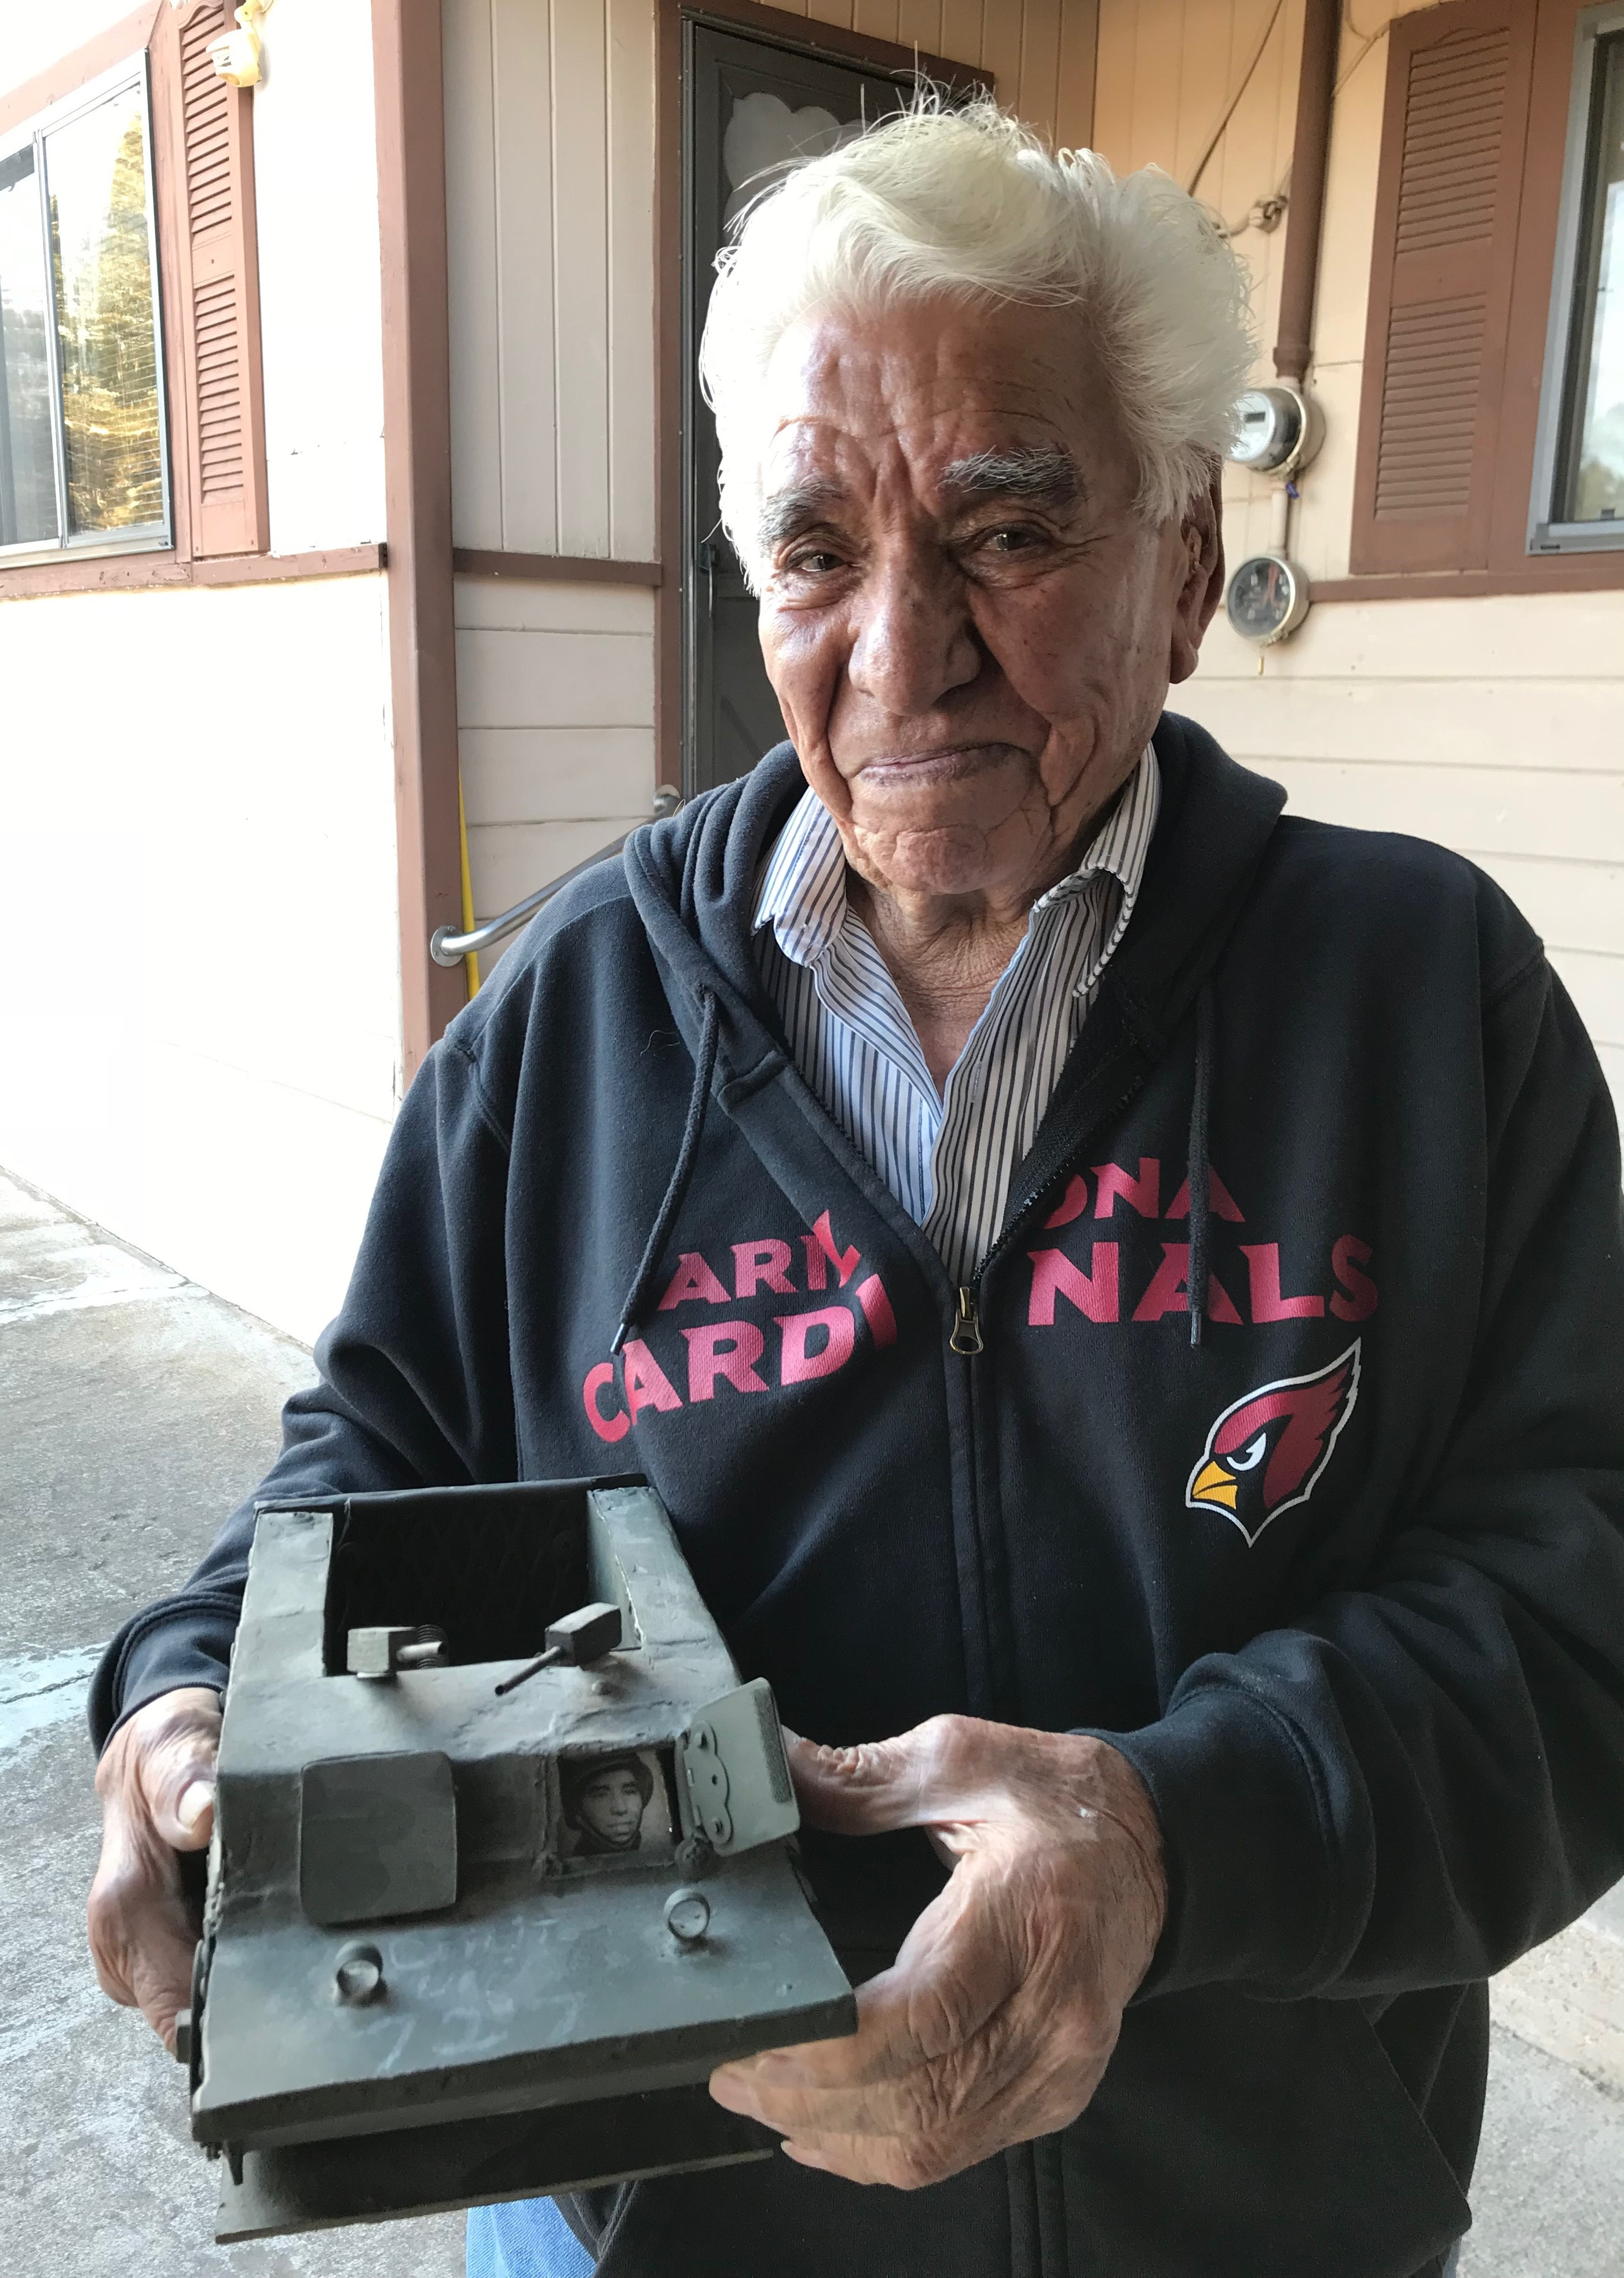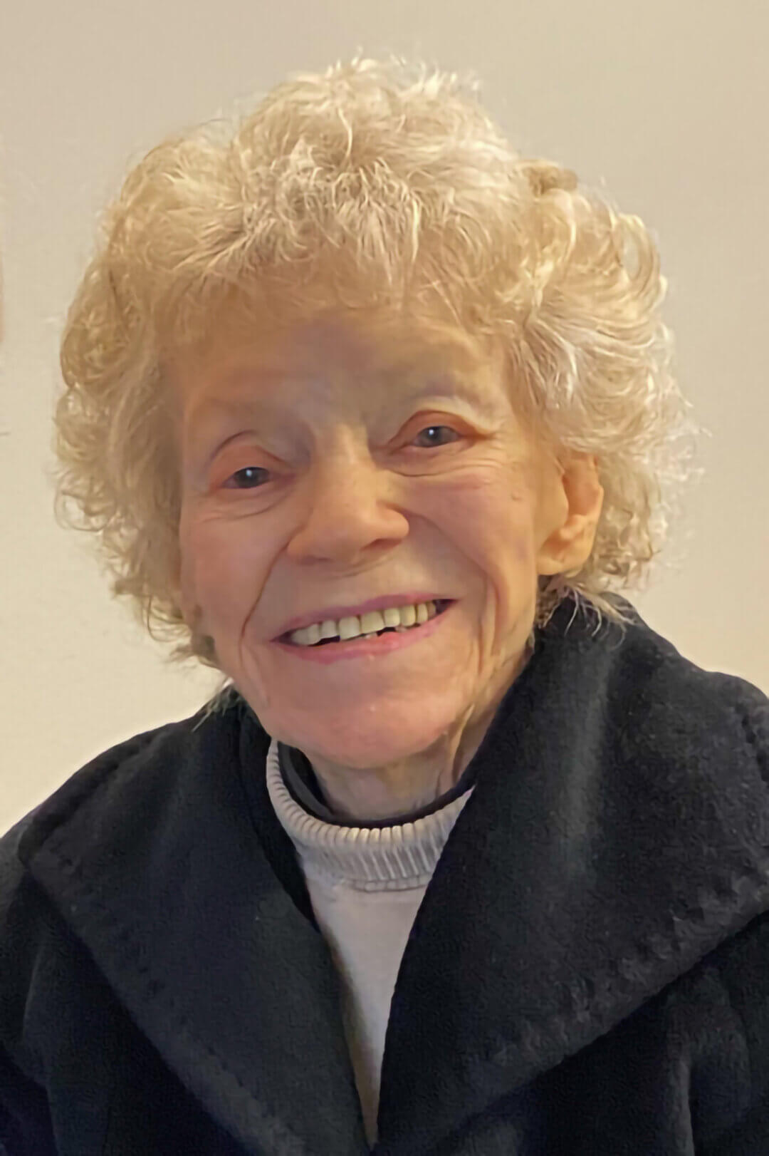
Bennie Torrez Arleen (Wilbur) Sorenson

